1. 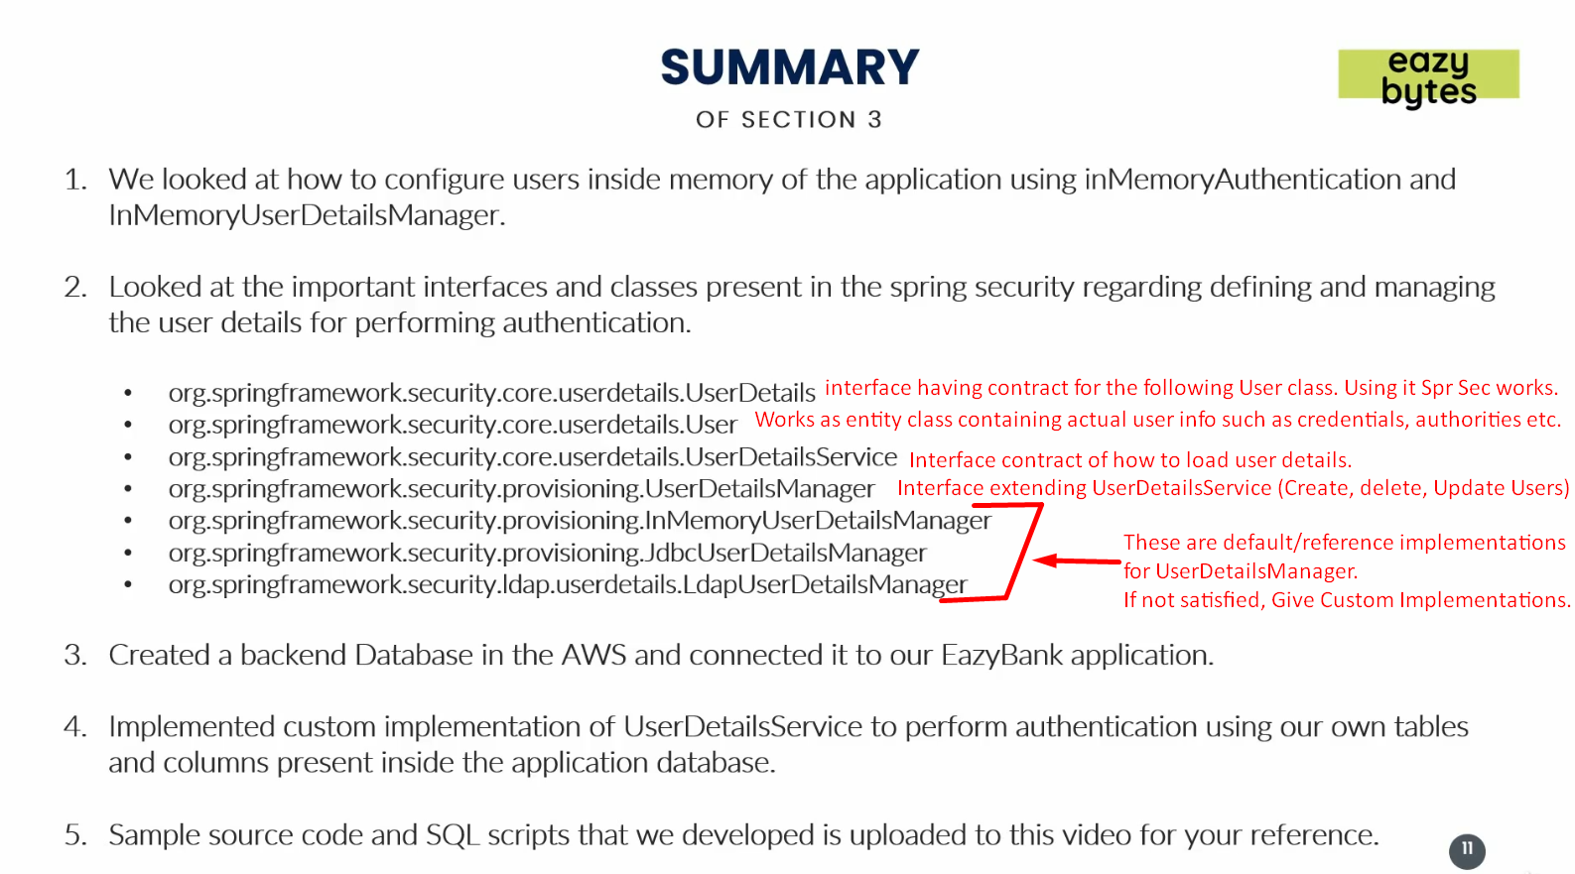
2. This has also resource file with named “springsecsection3.zip”. Look for it in the current folder.